

DevOps Lab

Troubleshooting Web Server issues
Home task

Prerequisites
IMPORTANT!! Please read task carefully. Current task should be performed using vagrant.
You have a broken site infrastructure (VM) which consists of:
- webserver (apache httpd)
- application server (apache tomcat)

SSH credentials of imported virtualbox machine are:
- Login: root
- Password: vagrant

There is no actual application deployed into tomcat.

TASK
You have to restore/fix tomcat default home page availability through httpd (port 80).

Once it’s done you are to fill table with found issues, put your investigations steps, define order of sorting all of this out, list utilities you used.

Files to be created during task execution:
- Fix script
- Modified Vagrantfile
- Fix report as PDF file

HOWTO

- Go to
- https://git.epam.com/epm-rdd1/Linux_DevOps_Lab/troubleshooting_task_1
or
- https://git.epam.com/epm-rdd1/Azure/troubleshooting_task_1
repository

- Create new branch from master with name accepting pattern Name_Surname:
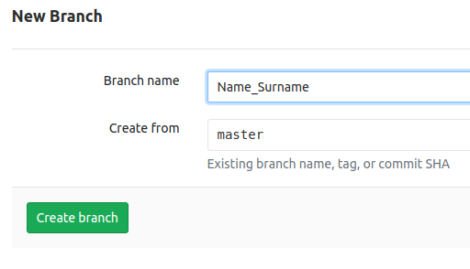
- Use your knowledge to create, clone, update and push your personal branch back to remote.

Acceptance criteria
- site is working;
- site will work after server reboot;
- firewall allows connections to 22 (ssh) and 80 (http) ports only;
- bash script which fixes issues is attached to the report;
- student understands what he/she deals with;

report pattern

# | Issue | How to find | Time to find | How to fix | Time to fix
1 | LoadModule errors | $ httpd -t | 1 min | Remove manual LoadModule strings and  Include conf.modules.d/*.conf in httpd.conf | 5 min
2 | Port 80 is in use by /usr/bin/nc | $ netstat -tulpan | grep 80 | 1 min | $ systemctl stop bindserver | 2 min
3 | Nc is reappearing after reboot | $ systemctl status bindserver | 1 min | $ systemctl disable bindserver | 1 min
4 | A suspicious cronjob for root user | $ crontab -l | 30 min | $ crontab -r | 1 min
5 | Suspicious iptables REJECTs | $ less /etc/sysconfig/iptables | 1 min | $ iptables -F; | 1 min
6 | Immutable attribute is set on /etc/sysconfig/iptables | $ lsattr file | 10 min | $ chattr -i /etc/sysconfig/iptables | 1 min
7 | No firewall rules to allow connections from 80 and 22 only | $ less /etc/sysconfig/iptables | 1 min | $ iptables -A INPUT -p tcp -m tcp --dport 80 -j ACCEPT  $ iptables -A INPUT -p tcp -m tcp --dport 22 -j ACCEPT  $ iptables -A INPUT -i lo -j ACCEPT  $ iptables -P OUTPUT ACCEPT  $ iptables -P INPUT DROP  $ iptables-save > /etc/sysconfig/iptables | 2 min
8 | site rewrites its IP to an unrecognizeable DN | $ curl -L <SERVER_IP> | 1 min | Remove entire VirtualHost section from httpd.config | 1 min
9 | vhosts.conf listens to /mntlab | $ less vhosts.conf | 1 min | Change mntlab/ to * | 1 min
10 | Jsp folder is unmounted by default | $ less vhosts.conf | 1 min | Use mount instead of UnMount | 1 min
11 | Workers have wrog names and Ips defined | $ less workers.properties | 1 min | Set name of worker to tomcat.worker and IP to <ServerIP> | 1 min
12 | Tomcat is not running | $ ps le | grep tomcat | 1 min | $ systemctl start tomcat | 1 min
13 | starting tomcat systemd service forces reboot | $ systemctl start tomcat | 1 min | Remove “init 6” command from tomcat init file | 5 min
14 | Tomcat error messages are missing | $ jounalctl -xe | 1 min | Remove stdout forwarding to /dev/null in tomcat service file | 1 min
15 | Wrong version of java is set | $ java -version | 1 min | $ sudo alternatives --config java <<< '1' | 2 min
16 | Wrong permissions on tomcat logs | $ journalctl -xe | 1 min | $ chown -R tomcat:tomcat logs
17 | Variables JAVA_HOME and CATALINA_HOME are set to /tmp (for user tomcat and globally too) | $ echo $JAVA_HOME; echo $CATALINA_HOME | 1 min | Edit /etc/environment for global setting and /home/tomcat/.bashrc for tomcat user setting | 15 min
18 | Tomcat service is now changed on disk | $ systemctl start tomcat | 1 min | $ systemctl daemon-reload | 1 min

